📄 **Personal Portfolio Website**

Title : Personal Portfolio Website

Submitted by: [Divya L]

Domain: [Full stack web development]

Institution: [Future interns]

Date: [27-07-2025]

**Objective**  
To design and develop a personal portfolio website that showcases skills, projects, and achievements using modern frontend technologies.

**Purpose:**  
A portfolio website acts as a digital resume and project showcase, helping developers present their work to potential employers and collaborators.

Scope:

This project focuses on frontend development using React.js and Tailwind CSS. Optional backend and SEO enhancements are planned for future updates.

**🛠️ Tools & Technologies Used**

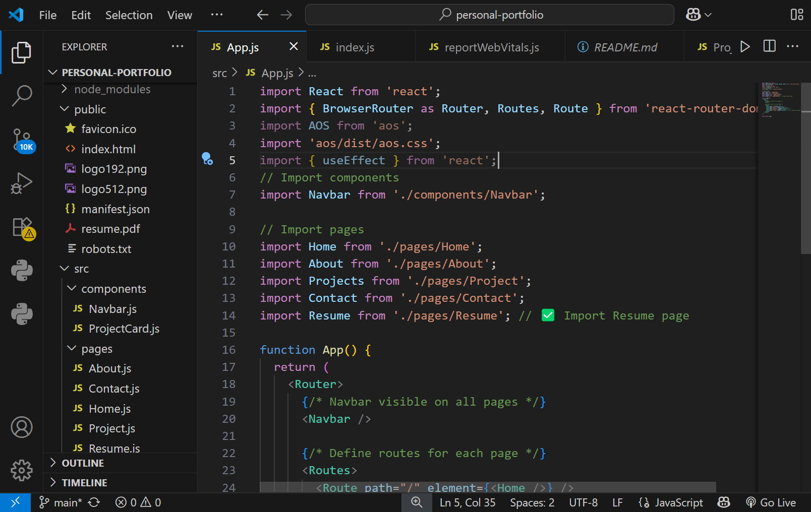

|  |  |
| --- | --- |
| Technology | Purpose |
| React.js | Component-based frontend development |
| Tailwind CSS | Utility-first styling and responsive design |
| React Router | Navigation between pages |
| AOS | Scroll-triggered animations |
| GitHub | Version control and project hosting |

**Website Architecture & Design**

* **Component Structure**:
  + Navbar: Sticky navigation with links to all sections
  + Home: Welcome message and introduction
  + Projects: Cards with images, descriptions, and links
  + Resume: Download and print buttons
  + Contact: Placeholder for future form integration
* **Routing**:
  + Implemented using React Router for seamless navigation
* **Styling**:
  + Tailwind CSS used for layout, spacing, typography, and responsiveness
* **Animations**:

AOS library used for scroll-triggered effects

**Features Implemented**

| **Feature** | **Description** |
| --- | --- |
| Interactive Resume - | Download and print options, styled layout |
| Project Showcase - | Cards with GitHub and Live Demo links |
| Responsive Design - | Mobile-first layout with adaptive components |
| Scroll Animations - | Smooth transitions for visual appeal |
| Modular Component -Architecture | Reusable and maintainable code structure |

**Challenges & Solutions**

**Challenges Faced**:

* + Staying focused during development
  + Debugging layout issues with Tailwind
  + Integrating animations without performance lag

**Solutions**:

* + Used focused playlists and time-blocking to stay productive
  + Followed YouTube tutorials and documentation for troubleshooting
  + Isolated components for easier debugging and testing

**Learnings**:

* Mastered React component structure
* Gained confidence in Tailwind CSS
* Learned to implement animations and routing effectively

**Future Scope**

**Contact Form Integration**:

* + Add a form with name, email, and message fields
  + Use Formspree or EmailJS for email notifications

**Dark Mode Toggle:**

* + **Improve accessibility and user experience**

**Blog Section:**

* + **Share articles, tutorials, or updates**

**Backend Integration (Optional):**

**Use Node.js and MongoDB for storing contact messages or blog posts**

Screenshots:

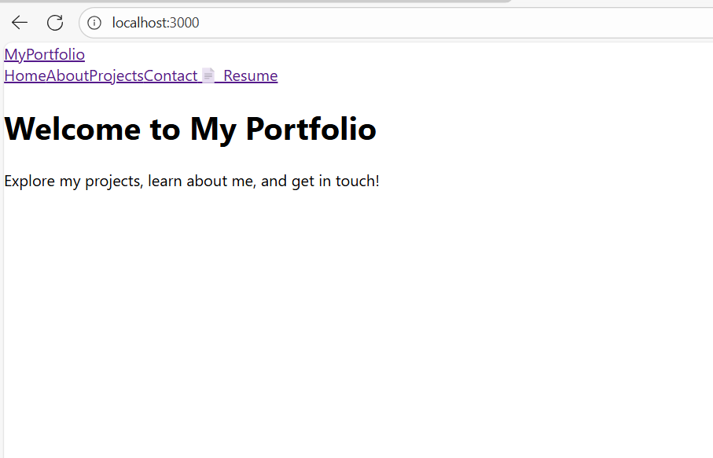  
 **Figure 1**: Landing section of the personal portfolio website featuring a sticky navigation bar and introductory text. This screen welcomes visitors and provides quick access to key sections like Home, About, Projects, Contact, and Resume

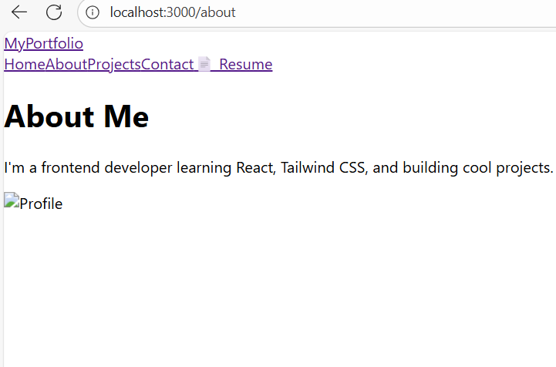

**Figure 2**: About Me section of the personal portfolio website, highlighting the developer’s focus on React, Tailwind CSS, and practical project-building. This section introduces the developer’s learning journey and technical interests.

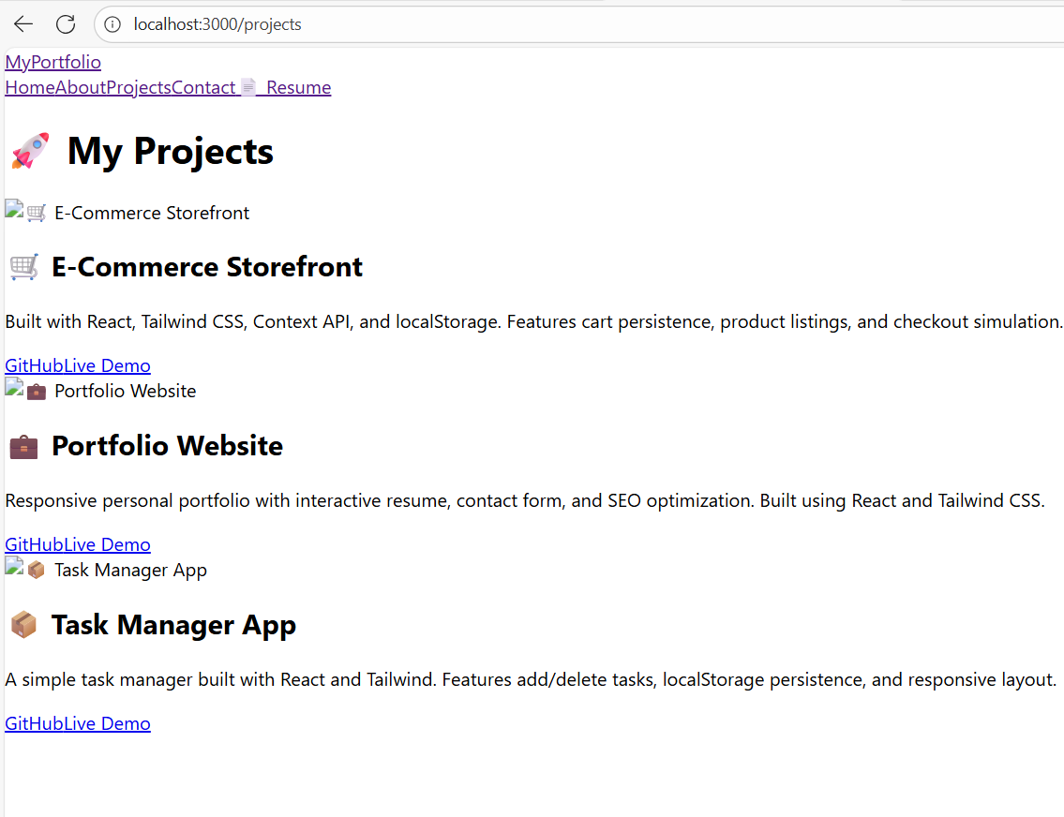

**Figure 3**: Contact Me section of the portfolio website featuring a form with fields for name, email, and message. This interface allows visitors to send inquiries directly, enhancing user engagement and accessibility.

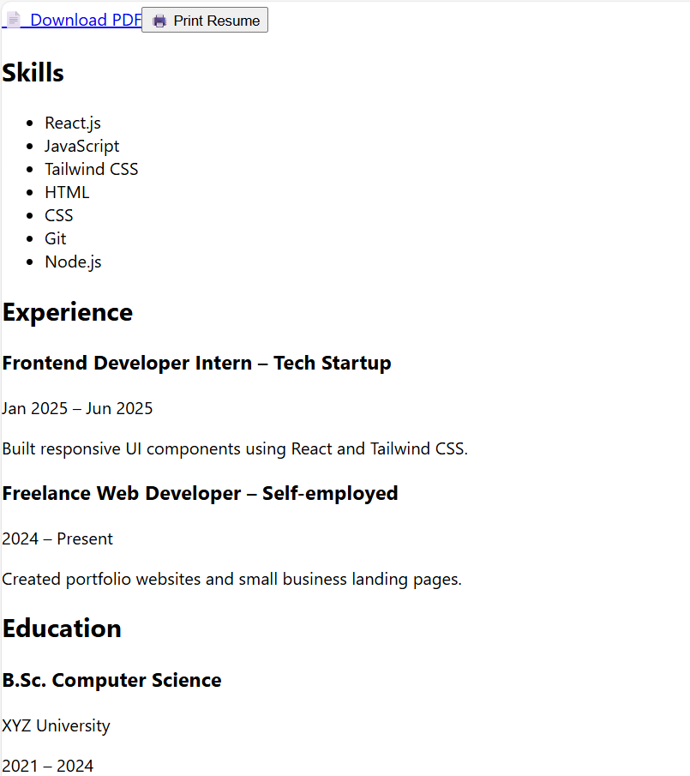

**Figure 4**: Resume overview highlighting core frontend skills (React.js, JavaScript, Tailwind CSS), practical experience through internship and freelance projects, and academic background in Computer Science (2021–2024).

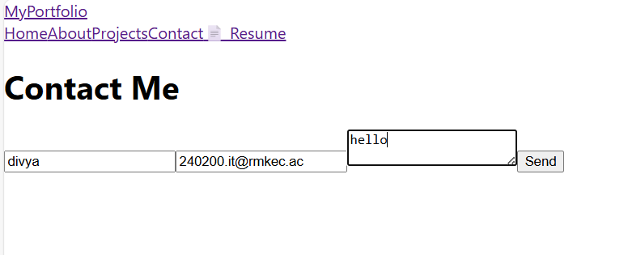

**Figure 5**: Contact Me section of the portfolio website featuring a form with fields for name, email, and message. This interface allows visitors to send inquiries directly, enhancing user engagement and accessibility.

📝 Conclusion

This portfolio project showcases my growth as a frontend developer, combining technical proficiency with thoughtful UI/UX design. Through modular React components, responsive layouts, and interactive features like scroll animations and sticky navigation, I’ve built a site that reflects both my skills and personality. The process deepened my understanding of component reuse, state management, and visual polish using Tailwind CSS and AOS.

Beyond the code, this project taught me the value of clarity, consistency, and user-centered design. It also reinforced the importance of documentation and iterative improvement. I’m proud of the outcome and confident that this portfolio will serve as a strong foundation for future opportunities—whether academic, freelance, or professional.